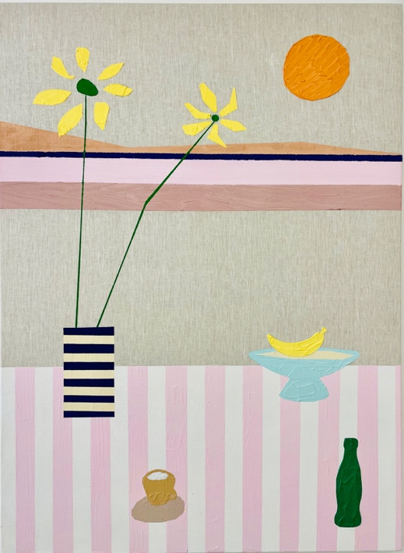
PRESSE RELEASE

Summer Vibes
Ben Arpea, Norbert Bisky, Carlo D’Anselmi, Anna Fasshauer, Séverin Guelpa, Lucia Hierro, Romane de Watteville
July 2, 2026 – September 12, 2026

Opening: La Nuit des Bains, July 2, 2026, 6 pm – 9 pm
Rue des Vieux-Grenadiers 2, 1205 Geneva

Ben Arpea
Sunflowers, 2023
Acrylic, oil and sand on linen
150 x 110 x 4.5 cm

Fabienne Levy Gallery is delighted to present Summer Vibes, a group exhibition bringing together seven gallery artists whose diverse practices converge around the atmosphere, sensations and emotional resonance of summer. Through painting, sculpture, textile and installation, the exhibition unfolds as a journey through luminous landscapes, vibrant color, tactile materials and suspended moments, exploring the season not simply as a time of year, but as a state of mind.

Color serves as the exhibition's common language. Whether radiant, atmospheric or intensely saturated, it becomes a vehicle for memory, perception and emotion. In the paintings of Ben Arpea, bold planes of color and textured surfaces blur the boundaries between geometric abstraction and figuration. Inspired by artists such as Joan Miró, David Hockney and Jonas Wood, Arpea reinvents the timeless genres of landscape and still life, distilling nature into vivid compositions where color becomes pure sensation.

This chromatic intensity finds a striking counterpart in the work of Norbert Bisky, whose unmistakable palette radiates with the brilliance of midsummer light. Oscillating between figuration and abstraction, his paintings capture moments of exuberance charged with underlying tension, reflecting the contradictions of contemporary life. Beneath their seductive luminosity lies a complex psychological landscape, where beauty and unease coexist.

Memory and imagination merge in the dreamlike paintings of Carlo D'Anselmi. Through strong brushworks and richly atmospheric hues, figures, animals and landscapes emerge only to dissolve again into painterly space. His works evoke the hazy quality of summer recollections, where time slows, forms soften and reality blends seamlessly with reverie.

Extending this dialogue with landscape into three dimensions, Séverin Guelpa explores the physical and poetic qualities of natural materials. Working with wood, stone and metal, his sculptures and installations investigate erosion, transformation and ecological fragility. His practice invites viewers to contemplate the environments that summer encourages us to rediscover, while reminding us of their vulnerability.

Questions of landscape give way to those of everyday life in Lucia Hierro's textile sculptures. Monumental recreations of familiar grocery-store products transform ordinary consumer goods into vibrant icons, combining the visual language of Pop Art with Minimalist aesthetics. Rooted in the cultural fabric of urban neighborhoods, her work reflects on identity, migration and systems of exchange, while bringing an unexpected sense of warmth, humor and familiarity to the exhibition.

This attention to intimacy resonates with the work of Romane de Watteville, whose delicate compositions inhabit the space between ornament and emotion. Her subtle visual language celebrates moments of quiet contemplation, offering a sense of lightness and freedom that echoes the slower rhythm and heightened sensitivity of the summer season.

Anna Fasshauer's sculptures extend the exhibition's exploration of color beyond the painted surface and into three-dimensional form. Shaped exclusively through repeated hammer blows, her aluminum works preserve the trace of every gesture, transforming raw force into luminous volumes. Finished in bold, saturated hues, the sculptures engage directly with the exhibition's vibrant chromatic language. Radiating energy, warmth and vitality, Fasshauer's works embody the exuberance of summer while revealing the expressive potential of material, gesture and color.

Together, these seven artistic voices create a dialogue between abstraction and figuration, landscape and domesticity, permanence and ephemerality. While each artist approaches these themes through a distinct visual language, they share an acute sensitivity to color, material and atmosphere. Summer Vibes celebrates the season as an experience that is at once sensory and emotional, a time when light transforms our perception of the world, memories become more vivid, and the ordinary takes on an unexpected intensity.

Avenue d’Ouchy 70 Rue des Vieux-Grenadiers 2 Rämistrasse 27
1006 Lausanne 1205 Genève 8001 Zürich
+41 21 711 43 20 +41 22 320 10 85 +41 44 253 11 24

www.fabiennelevy.com
@fabiennelevygallery
#SummerVibes #BenArpea #NorbertBisky #CarloDAnselmi #AnnaFasshauer #SéverinGuelpa #LuciaHierro #RomaneDeWattewille #FabienneLevy
Pour plus d’informations, veuillez contacter : info@fabiennelevy.com

