PRESSE RELEASE
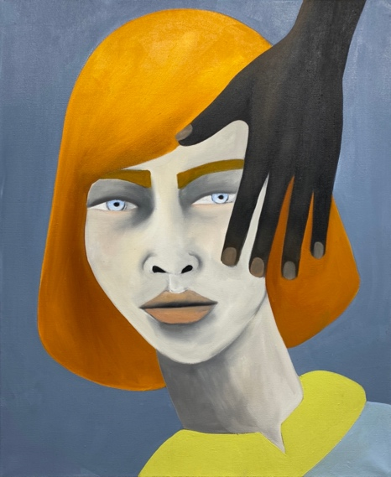
Rebecca Brodskis, Beaucoup, 2022, oil on linen, 61 x 50 cm
Shifting Grounds
Ben Arpea, Mattania Bösiger, Rebecca Brodskis, Carlo D’Anselmi, Séverin Guelpa, Anthony Miller, Tang Shuo, Yuval Yairi

July 5 – September 5, 2026
Avenue d’Ouchy 70, 1006 Lausanne

Fabienne Levy Gallery is delighted to present Shifting Grounds, a group exhibition bringing together artists whose works explore the unstable terrain between image and object, memory and material. Across painting, photography and sculpture, landscapes emerge as sites of transformation: surveyed, imagined, woven, excavated, or reconstructed. Rather than present fixed views of the world, these works reveal places and forms in flux, inviting the viewer to consider how meaning is continually shaped by movement, perception and change.

Together, these artistic practices reveal landscape not as a fixed backdrop but as a living field of transformation. Whether approached through memory, material or abstraction, each work reflects the shifting nature of the world we inhabit and the images we create. Shifting Grounds invites viewers to embrace uncertainty—not as instability, but as the condition through which landscapes, identities and ways of seeing are continually renewed.

www.fabiennelevy.com
@fabiennelevygallery
#ShiftingGrounds #FabienneLevy
For more information: info@fabiennelevy.com

